Experiment-15
Write A Python Program To Implement Decision Tree
Aim
To write a Python program to implement a Decision Tree for predicting whether a student will pass or fail based on study hours and attendance.
Algorithm
- Start the program.
- Initialize the training data with study hours and attendance.
- Assign the output labels as Pass or Fail.
- Define the decision tree rules.
- Get the student's study hours and attendance.
- Check whether the study hours are less than or equal to 3.
- If true, predict Fail.
- Otherwise, check whether attendance is less than or equal to 70.
- If true, predict Fail; otherwise, predict Pass.
- Display the predicted result.
- Stop the program.
Code
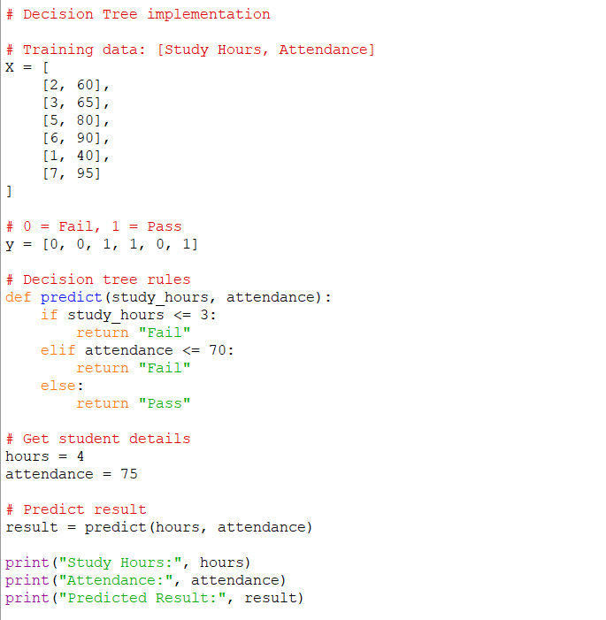
Output
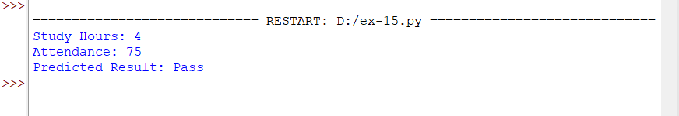
Result
The Decision Tree program was implemented successfully and predicted the student's result based on study hours and attendance.

